# CS 255 Business Requirements Document Template

Complete this template by replacing the bracketed text with the relevant information.

This template lays out all the different sections that you need to complete for Project One. Each section has guiding questions to prompt your thinking. These questions are meant to guide your initial responses to each area. You are encouraged to go beyond these questions using what you have learned in your readings. You will need to continually reference the interview transcript as you work to make sure that you are addressing your client’s needs. There is no required length for the final document. Instead, the goal is to complete each section based on your client’s needs.

**Tip:** You should respond in a bulleted list for each section. This will make your thoughts easier to reference when you move into the design phase for Project Two. One starter bullet has been provided for you in each section, but you will need to add more.

## System Components and Design

### Purpose

*What is the purpose of this project? Who is the client and what do they want their system to be able to do?*

* **Aspects of the Problem**: This project is for one of our new clients. Driver Pass is a newly created company that wants to market to customers at the DMV. The purpose of this project is the client/owner, Liam, wants to design a system to fill a void in the market when it comes to training students for the driving test at their local DMV.

**System Background**

*What does DriverPass want the system to do? What is the problem they want to fix? What are the different components needed for this system?*

* **Problem Statement**: Driver Pass wants a system that can provide better driver training to prevent its customers from failing their driving tests at the DMV. Ultimately, Driver Pass would like us to build a system that:
* That will enable customers to take online classes and practice tests.
* Handles requests and scheduling for on-the road-training.
* Provides access to company data to create, update, and delete from anywhere online.
* The system will be hosted in a web-based distributed environment in the cloud.
* The system shall have an administrator account with the ability to disable a package.
* The system shall have a secretary account.
* The system shall enable a user account for them to login to their profile, make/cancel reservations, and access tests and/or review previously taken tests.
* The system will have a driver account for road instructors.

### Objectives and Goals

*What should this system be able to do when it is completed? What measurable tasks need to be included in the system design to achieve this?*

* **High-Level Requirements**:
* System email accounts are available for the admin, maintenance, and secretary.
* User can make/cancel reservations for on-the-road training by logging into their account or by calling/visiting the office to schedule with the secretary.
* The login page has the option to login, create an account and reset password.
* The customer can specify the date, time, and the system checks if the desired slot is available.
* The system accesses the database to store/retrieve the date, time, car, and driver.
* The reservations page has fields to enter first name, last name, address, phone-number, and state.
* The system provides fields for the user/secretary to provide pick-up and drop off location information. System prevents different pick up and drop off locations.
* The user can log into their account and the user can select a tab that says packages
* The system opens a page with three packages listed.
* Package One details: Six hours in a car with a trainer.
* Package Two details: Eight hours in a car with a trainer and an in-person lesson where we explain the DMV rules and policies.
* Package The details: Twelve hours in a car with a trainer, an in-person lesson where we explain the DMV rules and policies—plus access to our online class with all the content and material. The online class also includes practice tests.
* The user’s choice is added to cart and the web page has an option to “proceed to checkout”.
* The user presses “proceed to checkout” and the system opens a page for the user to enter payment options.
* The payment page has fields to enter card number, expiration date, and security code.
* Payment page has a box for the user to check if they want to system to store their car information.
* The user is able to press ‘submit’ button and the system processes the transaction.
* The system stores the user’s credentials, redirects user to home page, and provides options to schedule reservations for two-hour slots and/or access the appropriate content.
* The system stores the user’s time remaining after scheduling a reservation.
* The system admin has the privilege to add and remove packages.
* The DMV is sent a link to login with a username and password.
* The DMV is taken to a specific page that list previous updates and provides tabs to update, remove, and create a new update.
* After the DMV presses upload, a notification is sent to the admin and maintenance system email accounts.
* The admin, maintenance, and secretary has access to the user’s stored information..

## Requirements

### Nonfunctional Requirements

*In this section, you will detail the different nonfunctional requirements for the DriverPass system. You will need to think about the different things that the system needs to function properly.*

#### Performance Requirements

*What environments (web-based, application, etc.) does this system need to run in? How fast should the system run? How often should the system be updated?*

* The access to company data is located in a distributed environment with cross-platform functionality for different operating systems including mobile devices.
* The interaction between the user and the system should not exceed 5 seconds.
* The web-based system is hosted and managed by the cloud service provider.
* The cloud service provider will provide regular updates.
* The system will have a back-end for one of our team members to scale, modify, and maintain the system.
* The Driver Pass application will leverage Oracle DB’s partitioning schemes to increase performance.
* The system will implement load balancing to reduce latency (Google, n.d.).
* The system will implement multi-threading to increase the responsiveness to the user.

#### Platform Constraints

*What platforms (Windows, Unix, etc.) should the system run on? Does the back end require any tools, such as a database, to support this application?*

* Linux will be the system for server-side development.
* The Linux hosting will be shared, flexible, and cheap. Linux is open source and does not require a license. The platform will support interacting with a relational database management system where requests are made with a structured query language (Red Hat, 2022).
* The Linux operating system will be more secure and efficient than Windows.
* Programming will be done using the cross-platform language java. Eclipse is a free open-source tool for the IDE.
* The team will configure the network interface, IP address, gateway, and netmask.
* The team will use a kernel to manage network communication, file management, and hardware integrations. The kernel will track memory, what processes are running, and process requests for service from processes (Red Hat, 2019). The kernel is open source and anyone can download and redistribute it.
* The Driver Pass application will use Oracle DB for storage management. This tool will provide transaction processing, reservation retrieval, stored customer information.
* A web-based application in a distributed environment will require a mechanism that allows the processes to exchange data and information. This will require shared memory.
* Each concurrent process will access different methods (sub-problems) or the same methods depending on the required task.
* The user’s operating platform may not be able to process the incoming information and the application will need to govern the flow of information by creating a que (a list of information) or stack (Silberschatz, Galvin, Gagne, 2022).

#### Accuracy and Precision

*How will you distinguish between different users?* *Is the input case-sensitive? When should the system inform the admin of a problem?*

* Implements case-sensitive Role-Based Authentication with privileges sub-divided into admin, IT admin, secretary, user, and DMV.
* The application will implement role-based security rights associated with a principal object (Microsoft, 2021).
* The Driver Pass application will require 100% uptime and Linux will be the better choice.
* The Driver Pass data processing and accuracy will be enhanced by leveraging Oracle DB’s automatic storage management (Oracle, 2019).
* The Driver Pass system will implement the cloud service provider’s data back up and restoration capabilities. Backing up the data can prevent the data from being corrupted and/or enable the data to be restored to a previous point.
* Notifications shall be sent to the administrator, secretary, and/or technician will there is a service interruption or breach.

#### Adaptability

*Can you make changes to the user (add/remove/modify) without changing code? How will the system adapt to platform updates? What type of access does the IT admin need?*

* The system will adapt to platform updates by utilizing system utility programs. The programs will provide file management and system administration. Additionally, the technician will manage network settings and disk partitions. Linux has a central location where developers can find and download applications like Ubuntu to manage applications in a distributed network.
* The admin and/or IT admin shall access the REST authorizer.
* The admin shall enable/disable packages, reset passwords, make changes to customer information by logging into the system with the valid credentials. Afterwards, he can utilize predefined operations to add/modify/remove accounts without changing the code.
* Additionally, the system will have a Rest Controller that will restrict methods to only authenticated users in the Roles Allowed annotation with Admin or IT Admin passed as a parameter.

#### Security

*What is required for the user to log in? How can you secure the connection or the data exchange between the client and the server? What should happen to the account if there is a “brute force” hacking attempt? What happens if the user forgets their password?*

* The Linux operation system in a distributed environment will be more secure.
* The Linux operating system will incorporate Zero Trust IT security. Zero Trust is based on the principle of designing network security where every interaction begins in an untrusted state. It will prevent gaps in security architectures that implement one-time authentication (Red Hat, 2022).
* The Zero Trust security will segment access and will limit user permissions to specific operations (Red Hat, 2022).
* The admin, maintenance, and secretary will not have access the customer’s financial information.
* The system implements two-factor authentication for name and password.
* A secure connection between the client and server shall be accomplished with a domain name system lookup, a transmission control protocol handshake, and a secure transport layer security negotiation. The TLS will handle encryption, authentication, and integrity (Red Hat, 2019).
* Administrator shall have full access over all accounts.
* Administrator shall be able to control access to the system in the event of employee termination.
* Administrator shall be able to reset passwords when customers forget their password.
* The application will have a modular design and not every method will be able to assert a privilege. A method will make a request and another method will grant or deny the request.

### Functional Requirements

*Using the information from the scenario, think about the different functions the system needs to provide. Each of your bullets should start with “The system shall . . .” For example, one functional requirement might be, “The system shall validate user credentials when logging in.”*

* The system shall provide CRUD operations for the admin and/or IT admin (reservations, cancelations, and modifications) that are stored with the associated role-based signature that performed the operation.
* The system shall enable the user to make/cancel reservations for on-the-road training by logging into their account.
* The system shall store the pickup and drop-off location in the database.
* The system shall enable the secretary to make/cancel reservations and view current reservations.
* The system shall provide functionality for the secretary to store first name, last name, address, phone number, state, and their credit card number, expiration date, and security code in the database.
* The system shall accept user input to select a package and the system adds package to cart.
* The system shall facilitate customer check-out and transaction by retrieving card number, expiration date, and security code.
* The system shall store the customer’s card information with customer approval.
* The system shall store the user’s chosen package.
* The system shall modify user’s information relative to reservations made and benefits remaining in package.
* The system shall access the database to store/retrieve the date, time, car, and driver.
* The system shall enable the admin to add/remove packages.
* The system shall provide functionally for the DMV to login with a username and password
* The system shall store, apply, and display updates, removals, and new updates performed by the DMV.
* The system sends a notification to the admin and secretary email account after the DMV completes an update, removal, and/or creates a new update.

### User Interface

*What are the needs of the interface? Who are the different users for this interface? What will each user need to be able to do through the interface? How will the user interact with the interface (mobile, browser, etc.)?*

* The user interface page shall have the company logo at the top of the home page.
* The user interface page shall have dialogue boxes of varying sizes with descriptions and links to take the user to the desired page. Please refer to client diagram
* The user interface shall display options: online test progress, user information, driver notes, special needs, driver photo, and student photo.
* User will press online test progress and the system shall open a page that displays the test taken, test in-progress.
* The test shall display details: test name, time taken, score, and status.
* The test shall display status options: not taken, in progress, failed, or passed.
* The driver notes link shall take the user to a page with a table format with columns for the user/secretary to enter the lesson time, start hour, end hour, and driver comments.
* The home page shall have a tab that says ‘contact us’
* After clicking, the user shall be taken to a page that list the contact information of the company.

### Assumptions

*What things were not specifically addressed in your design above? What assumptions are you making in your design about the users or the technology they have?*

* The user understands the English language.
* The user has a computer and/or mobile device.
* The user has the computer literacy needed to navigate the system.
* The user has an internet connection.
* The user has a credit or debit card to purchase packages online.
* The system is accessible 24 hours a day and 7 days a week.
* The client has established a user/access agreement with the DMV.
* The client is available for user testing and feedback.
* There is an appropriate number of team members to complete the project.
* The team is proficient with JVM, eclipse, network integration, Linux, and Oracle DB.

**Rationale**: The system will be written, displayed, and accepts input using the English language. User’s of the system will have to understand the English language to comprehend the content. The user will need an internet connection and a computer or mobile device to view the web application. The client interview mentioned card information. I assume that the Driver Pass will not accept alternate forms of payment such as PayPal. Customers using the application might access the system at different times distributed across different life styles. The client did not state if they will be available for user testing and feedback. The scope of the project may change but I think we have enough team members to equally distribute tasks across the team in an effort to prevent silos. The team is comprised of subject matter experts that should be familiar with JVM, eclipse, network integration, Linux, and Oracle DB.

### Limitations

*Any system you build will naturally have limitations. What limitations do you see in your system design? What limitations do you have as far as resources, time, budget, or technology?*

* Use of the online application requires an internet connection.
* The system will require coordinated activities and shared resources managed by the storage management system (in this case Oracle).
* The system will not be accessible if the host provider has a service interruption.
* The supported web browsers are dictated by the cloud host provider.
* The budget was not explicitly mentioned during the interview. The project expenses at completion shall be under or equal to the client service agreement.
* The storage space is scalable but limited to the budget allocated for storage and memory.
* The system shall be deployed on or before May 8th.

**Rationale:** The are different people that will access the same information and these requests for access may occur at the same time. The system will have to coordinate these activities to ensure consistency, durability, accuracy, and integrity. The customers, secretary, and admin may have different web browser preferences. The support browsers are dictated by the host provider. The capabilities of Oracle DB implemented by the system is dependent upon the services purchased by client. Some Oracle DB services may not be available because of budget constraints. Financial resources must be properly allocated to ensure client satisfaction and increase profit maximization for our company. Additionally, the client wants to deploy the system on or before May 8th to satiate summer demand.

### Gantt Chart

*Please include a screenshot of the GANTT chart that you created with Lucidchart. Be sure to check that it meets the plan described by the characters in the interview.*

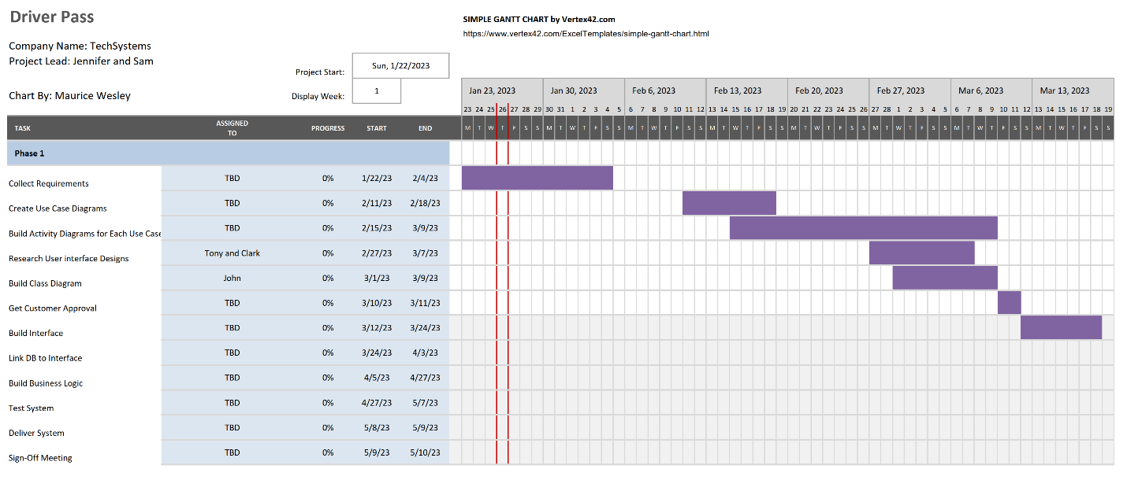

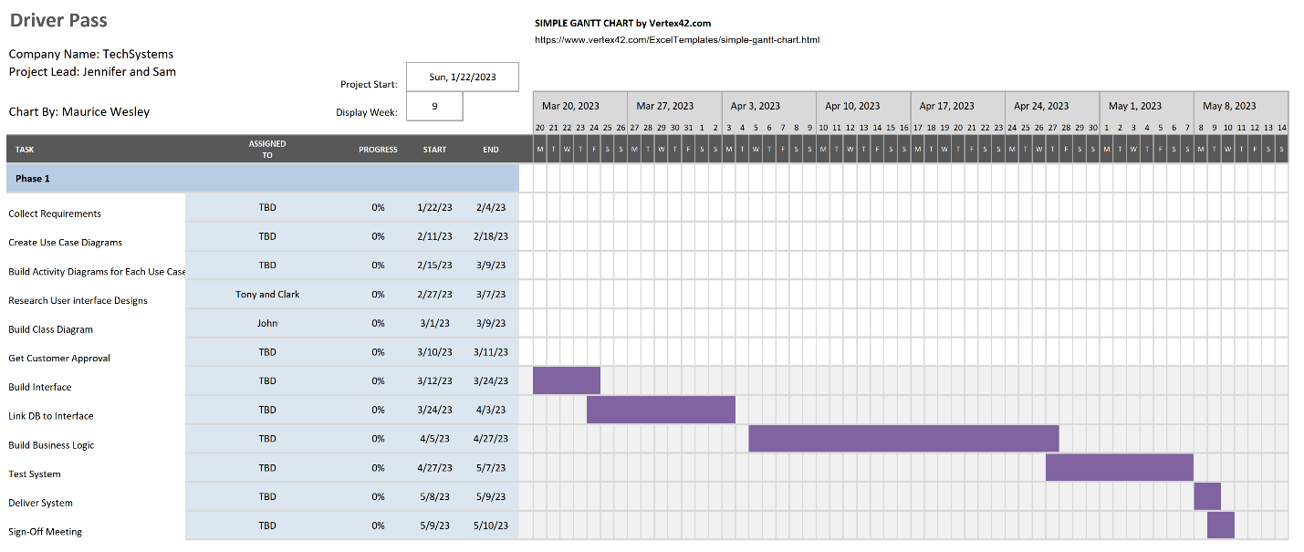

Sources

Silberschatz, Galvin, Gagne. (2022). *Operating system concepts*. [White Pages]. [Title Page | Operating System Concepts, 8th Edition (oreilly.com)](https://learning.oreilly.com/library/view/operating-system-concepts/9780470128725/silb_9780470128725_oeb_tp_r1.html)

MDN. (2022, October 6). *Understanding latency - Web performance*. Mozilla. [Understanding latency - Web performance | MDN (mozilla.org)](https://developer.mozilla.org/en-US/docs/Web/Performance/Understanding_latency)

Google. (n.d.). *Optimize application latency with load balancing*. Google Cloud. [Optimize application latency with load balancing  |  Load Balancing  |  Google Cloud](https://cloud.google.com/load-balancing/docs/tutorials/optimize-app-latency)

Red Hat. (2019). API security. [Blog Post]. [What is API security? (redhat.com)](https://www.redhat.com/en/topics/security/api-security)

Red Hat. (2022). What is zero trust. [Blog Post]. [What is Zero trust? (redhat.com)](https://www.redhat.com/en/topics/security/what-is-zero-trust)

Oracle. (2019). Automatic Storage Management. [White Paper]. [Oracle_19c_ASM_OverviewV1](https://www.oracle.com/docs/tech/database/asm-new-features.pdf)

Microsoft. (2021). Principal and Identity Objects. [Blog Post]. [Principal and Identity Objects | Microsoft Learn](https://learn.microsoft.com/en-us/dotnet/standard/security/principal-and-identity-objects)

Red Hat. (2022). 3 ways to configure a network interface in Linux. [Blog Post]. Retrieved November 27, 2022 from [3 ways to configure a network interface in Linux | Enable Sysadmin (redhat.com)](https://www.redhat.com/sysadmin/network-interface-linux)